1. Division of Seasons:

1.1 Maximum Temperature Approach:

Meteorological seasons are based on the annual temperature cycle and are commonly used by meteorologists to simplify weather forecasting and climate monitoring.

In the meteorological seasons, the year is divided into four seasons of approximately three months each. The seasons are defined based on the three-month periods of the year with the highest and lowest average temperatures.

In the case of The Island, there are 28 days each year. Therefore we simply divide each year into 4 halves and we have 7 days each half. And observe the average maximum temperature in 203 years (135/01 - 337/01)

Firstly, we obtained average temperature in each year (203 years) from 6 weather stations. We can see that 6 regions share the higher similar average maximum temperature when we compare every single row.

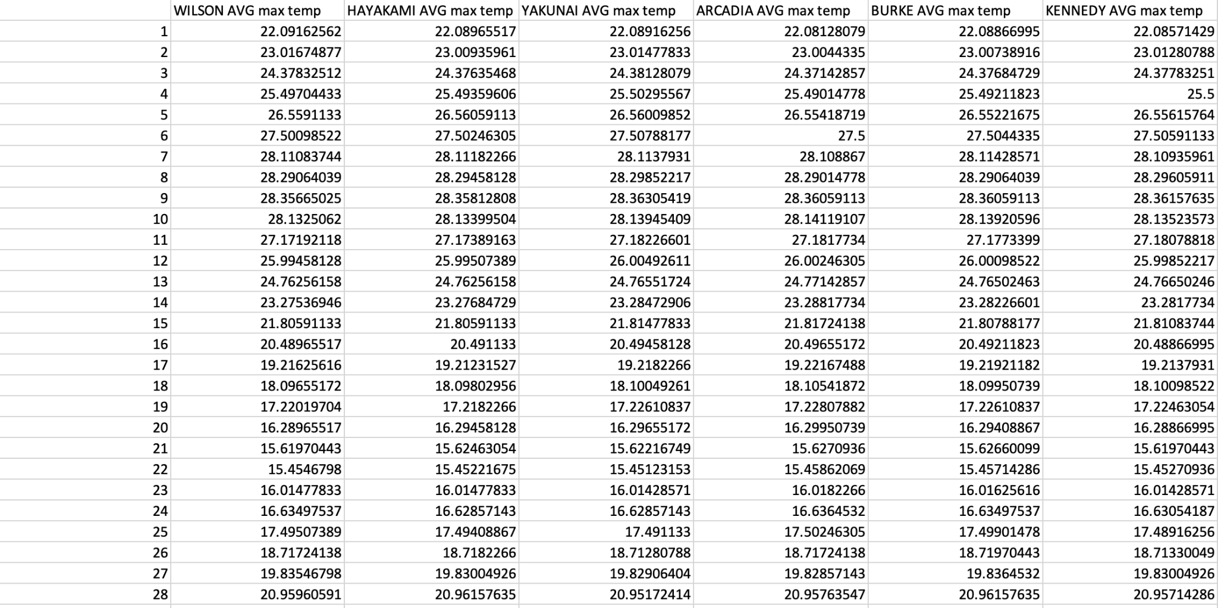

Due to the highly similarity of maximum temperature of each day in different stations, we can apply sorting the 6 columns of data in descending order altogether. And divide those data into 4 halves (indicated by different colours).

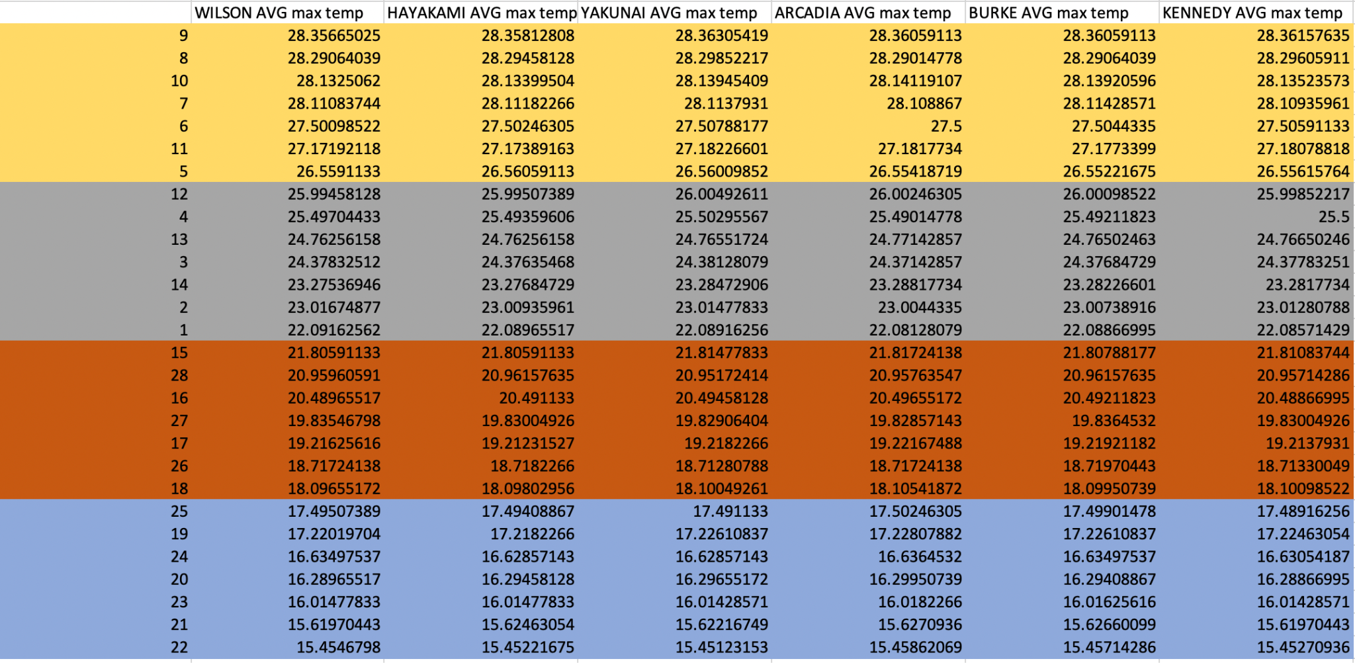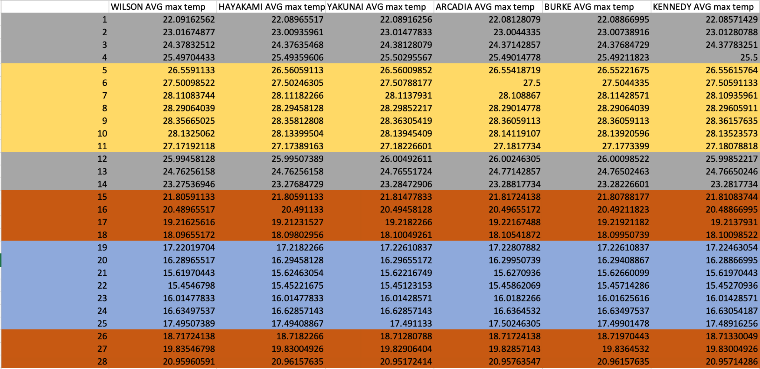

After sorting :

On overall: Highest average maximum temperature: day 9

Lowest average maximum temperature: day 22

Turning point : day 10(from increase to decrease) & day 23 (from decrease to increase)

Noting that summer is the hottest season and winter is the coolest season, we can conclude that day 9 must be summer and day 22 must be winter. Then, arrange the data again in ascending order of day. Sort it by order again and we can obtain how the colour regions are distributed. (Note: Yellow and blue one appears continuously for 7 days.)

Since day 9 must be summer and day 22 must be winter. Therefore, day 5 to day 11 is summer and day 19 to day 25 is winter.

Meteorological Season can be sorted as follows:

Spring : day 26 - day 4 Summer: day 5 - day 11

Autumn : day 12 - day 18 Winter: day 19 - day 25

1.2 Rainfall Approach

We can divide dry seasons and wet seasons in a year if we can see a periodic change in rainfall in each place.

Again, we sorted the data by descending order of rainfall in 6 weather stations of Providence respectively, and divided into 2 halves.

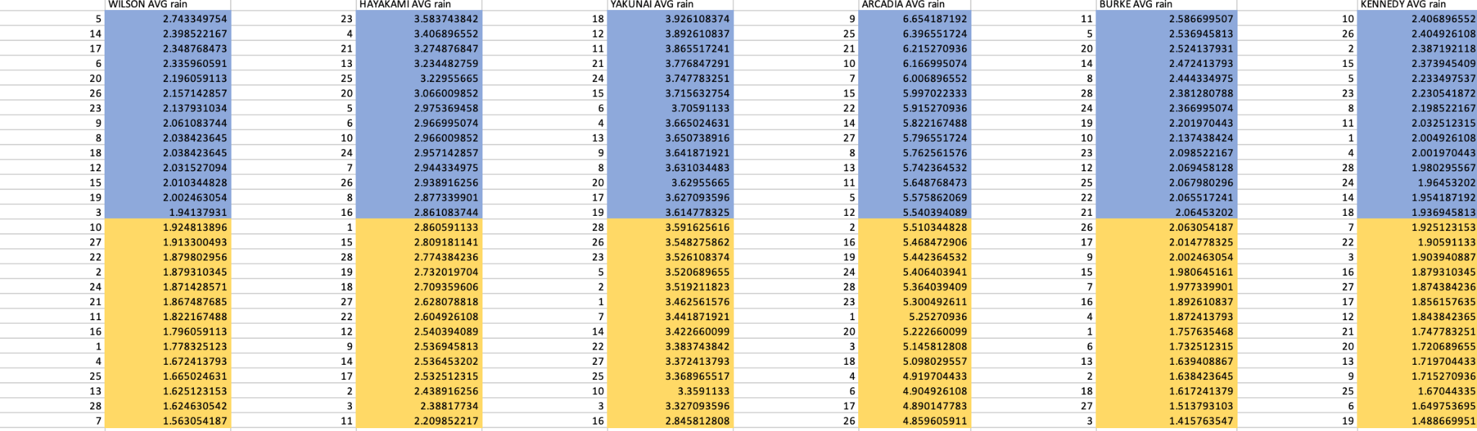

Since 6 weather stations obtain quite different amount of rainfall in 7 days on average. We sort them separately.

And we sort them back again:

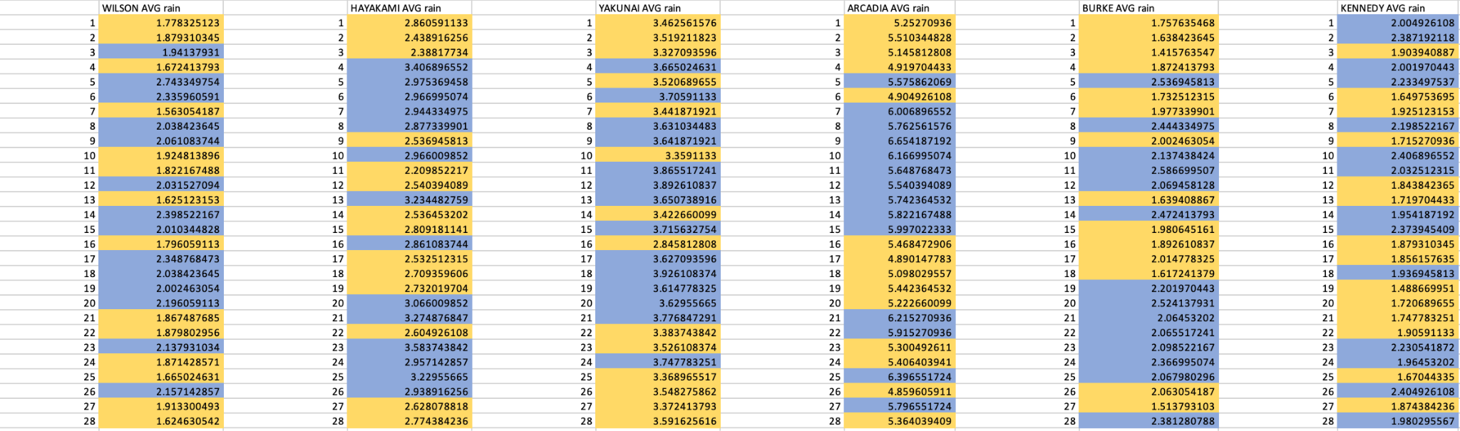

We can spot that not all weather stations show a continuous trend. We can only spot that Arcadia had a rain season from day 7 to day 15 on average, Burke had a rain season from day 19 to day 25. Which is quite different. Therefore, we can conclude that for the whole island, we cannot divide it into a rain and a dry season since there is no trend on each of them.

1. Variations of climate between weather stations

We monitor the maximum temperature and rainfall by comparing the trend day to day of each weather station in 203 years.

However, when we plot them directly, there will be so many lines and they would become hard to handle data visualization. Therefore, we had made it simple, which only considers the average maximum temperature and rainfall of day 1 to day 28 each year.

2.1.1 Trend of maximum temperature

Here is the trend of average maximum temperature per day of 6 weather stations.

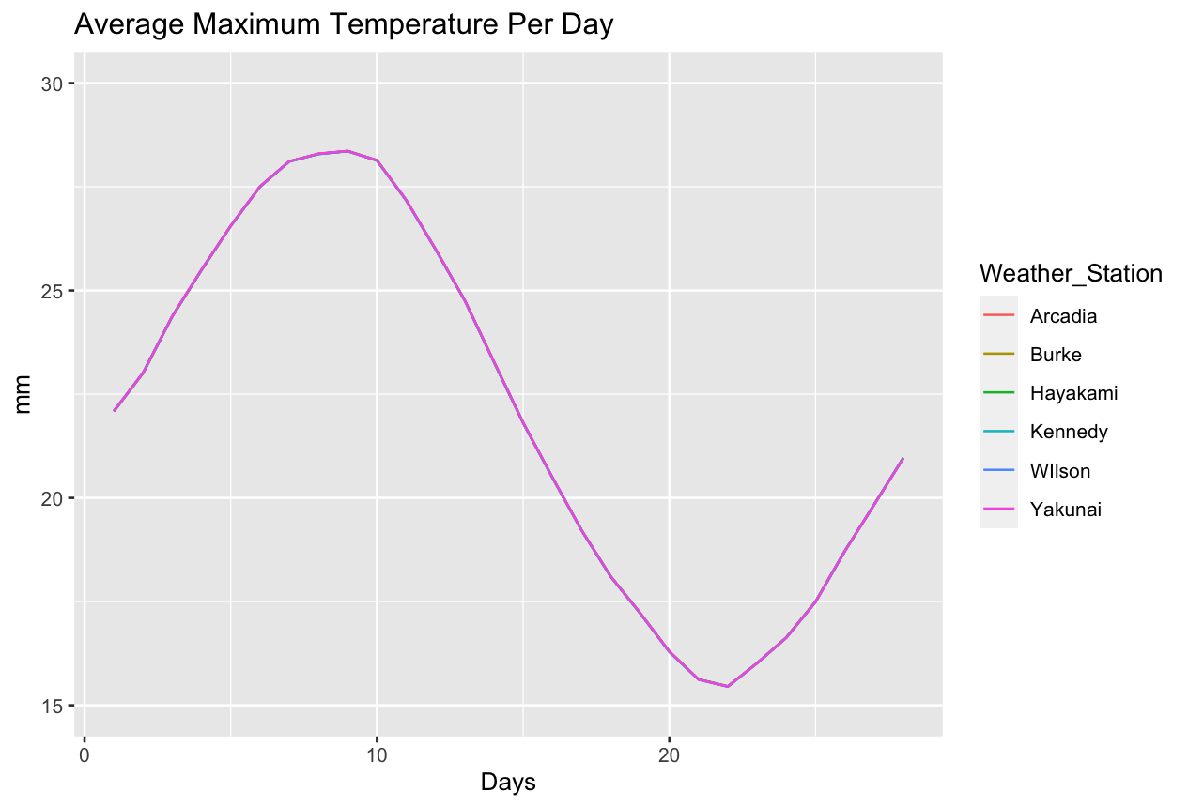

As we mentioned in 1.1, 6 regions share a highly similar average temperature per day in 203 years. So, the graph of 6 weather stations almost overlapped together to become the identical graph. However, we are not going to conclude that there is no variation in temperature.

2.1.2 Variations of Maximum temperature

We plot the maximum temperature of 6 weather stations of day 1 to day 28 by boxplot.

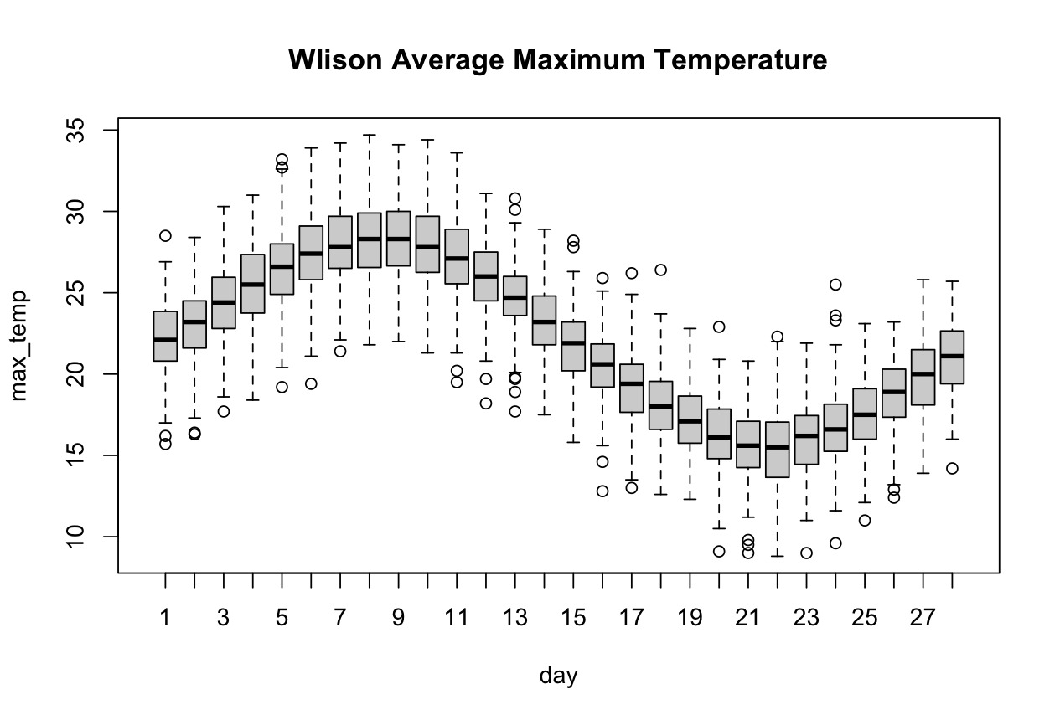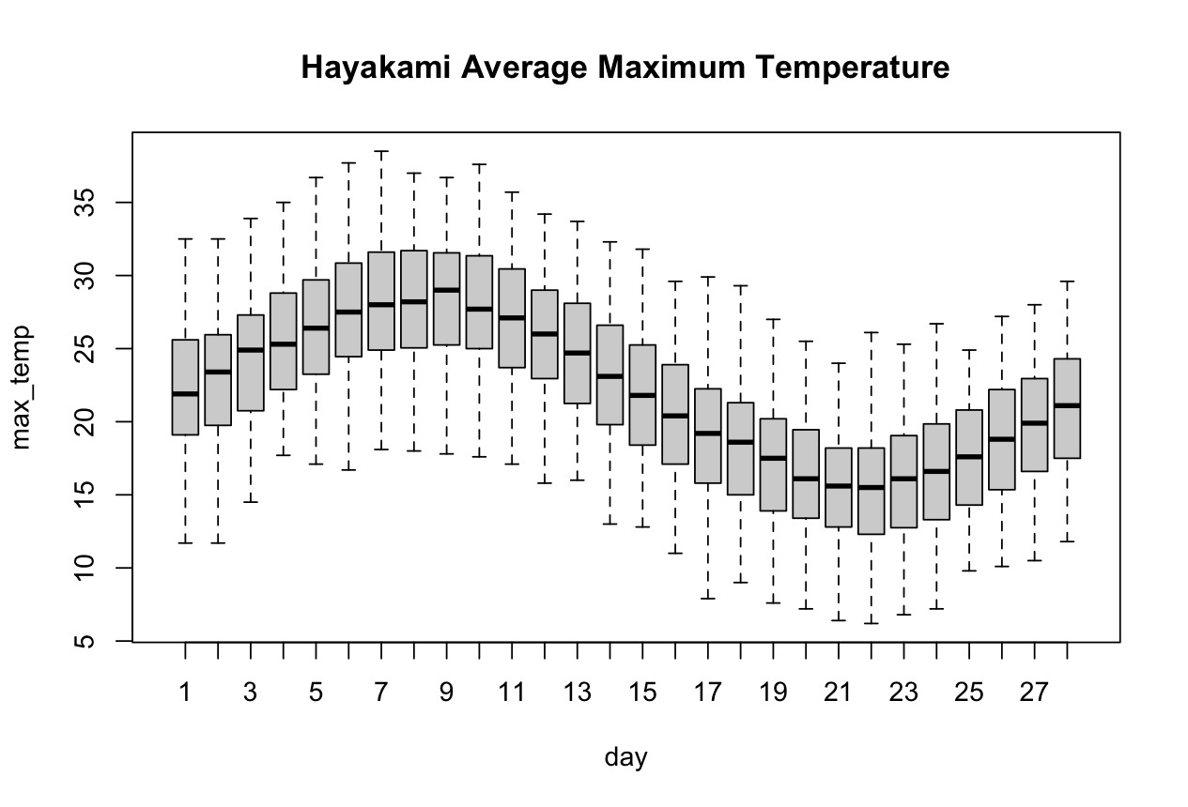

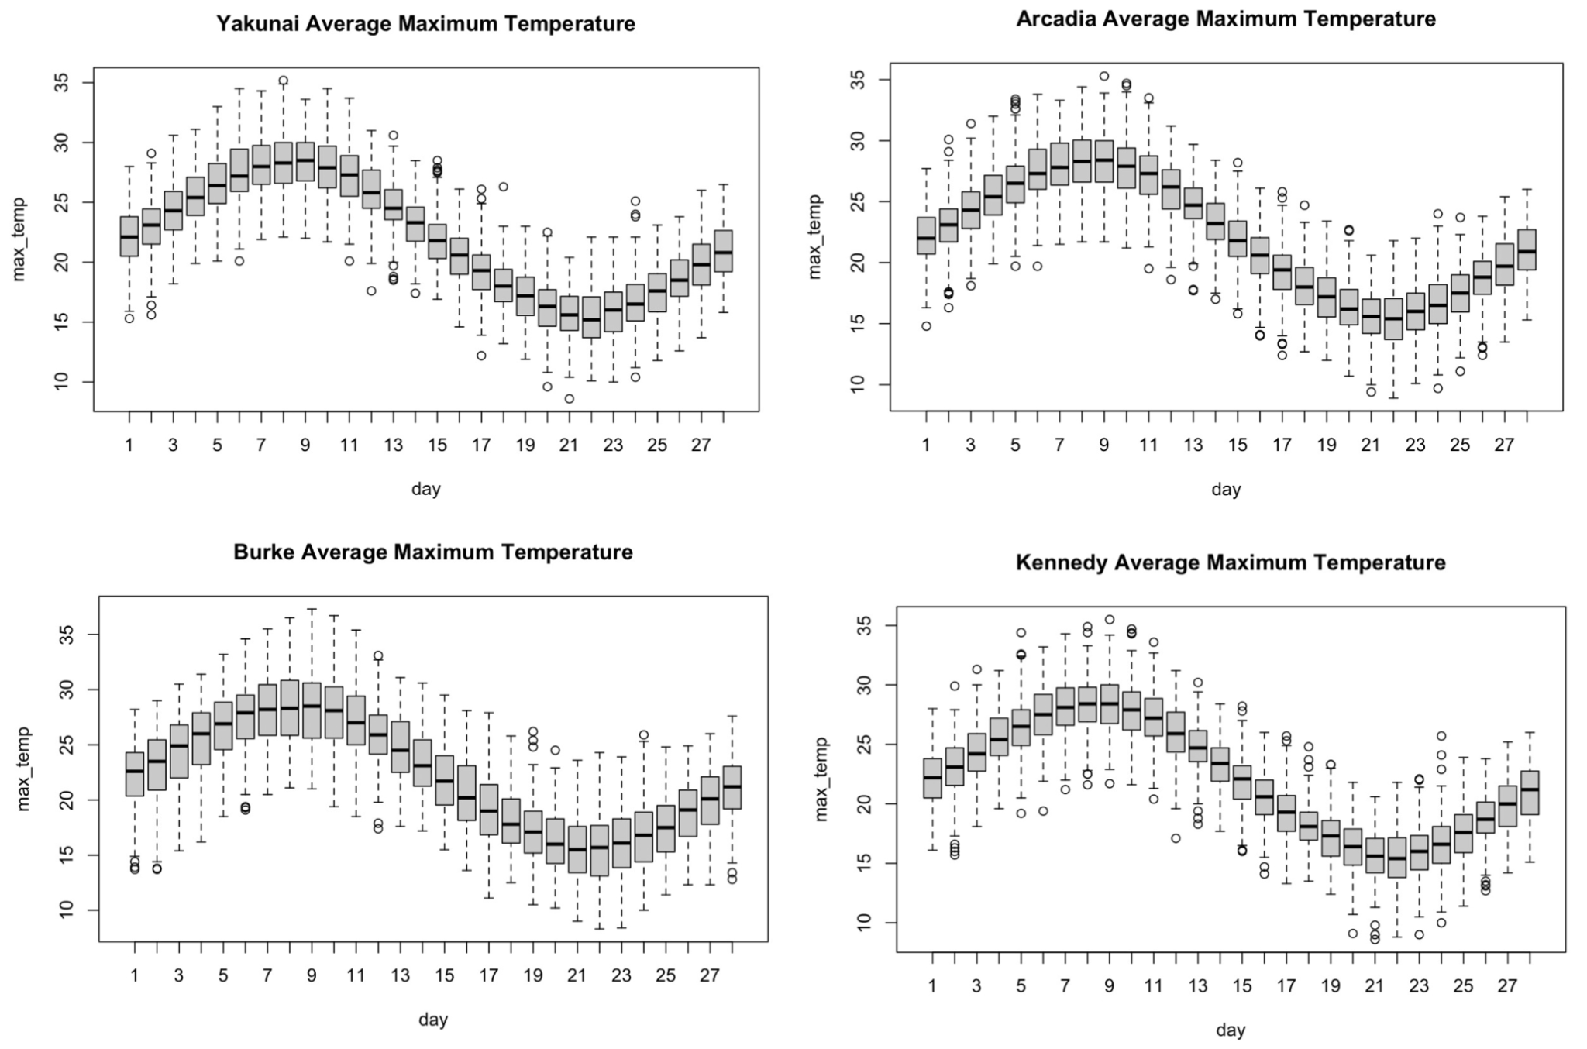



From the 6 boxplots above, we can notice that Hayakami had no outliers in 28 days of 203 years, which indicates that this station has the most stable temperature on each day of every year. While Kennedy, Yakunai and Arcadia show a relatively great amount of outliers among 6 stations, which indicates that the maximum temperature of those 3 places have a higher variance than the other stations.

Therefore, from the plot above, we can conclude that the temperature varies on Providence. Which is determined by the amount of outliers in the boxplot.

2.2 Variations of Rainfall

We also monitor the rainfall by taking the average of each day across 203 years.

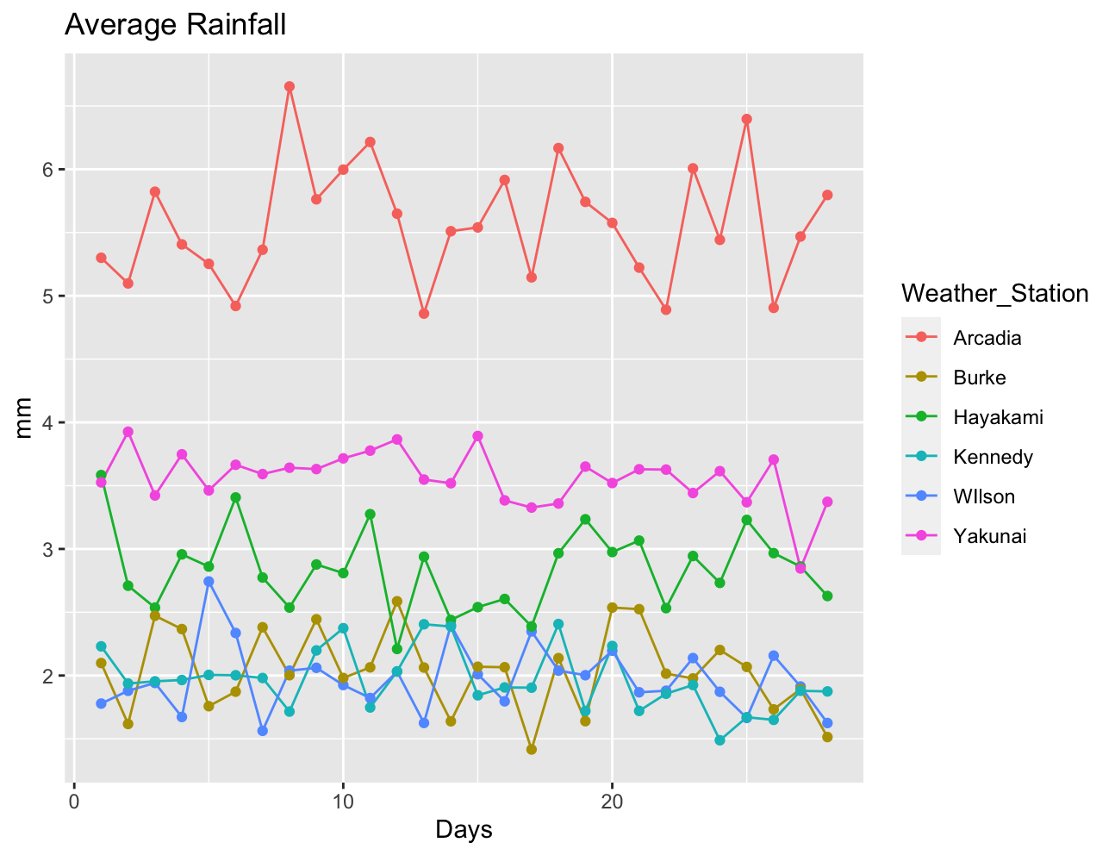

Obviously, Arcadia has a much higher rainfall than the other places , with ranges between 4.86 mm and 6.65 mm. Yakunai has the second largest rainfall with a range of 2.84 to 3.93. Then followed by Hayakami. And the other 3 stations recorded similar ranges of rainfall in a lower level among the others. Therefore, the rainfall indeed varies on Providence by simply comparing the weather stations’ average rainfall per day.

Again, we obtained the boxplot of rainfall of 6 stations:

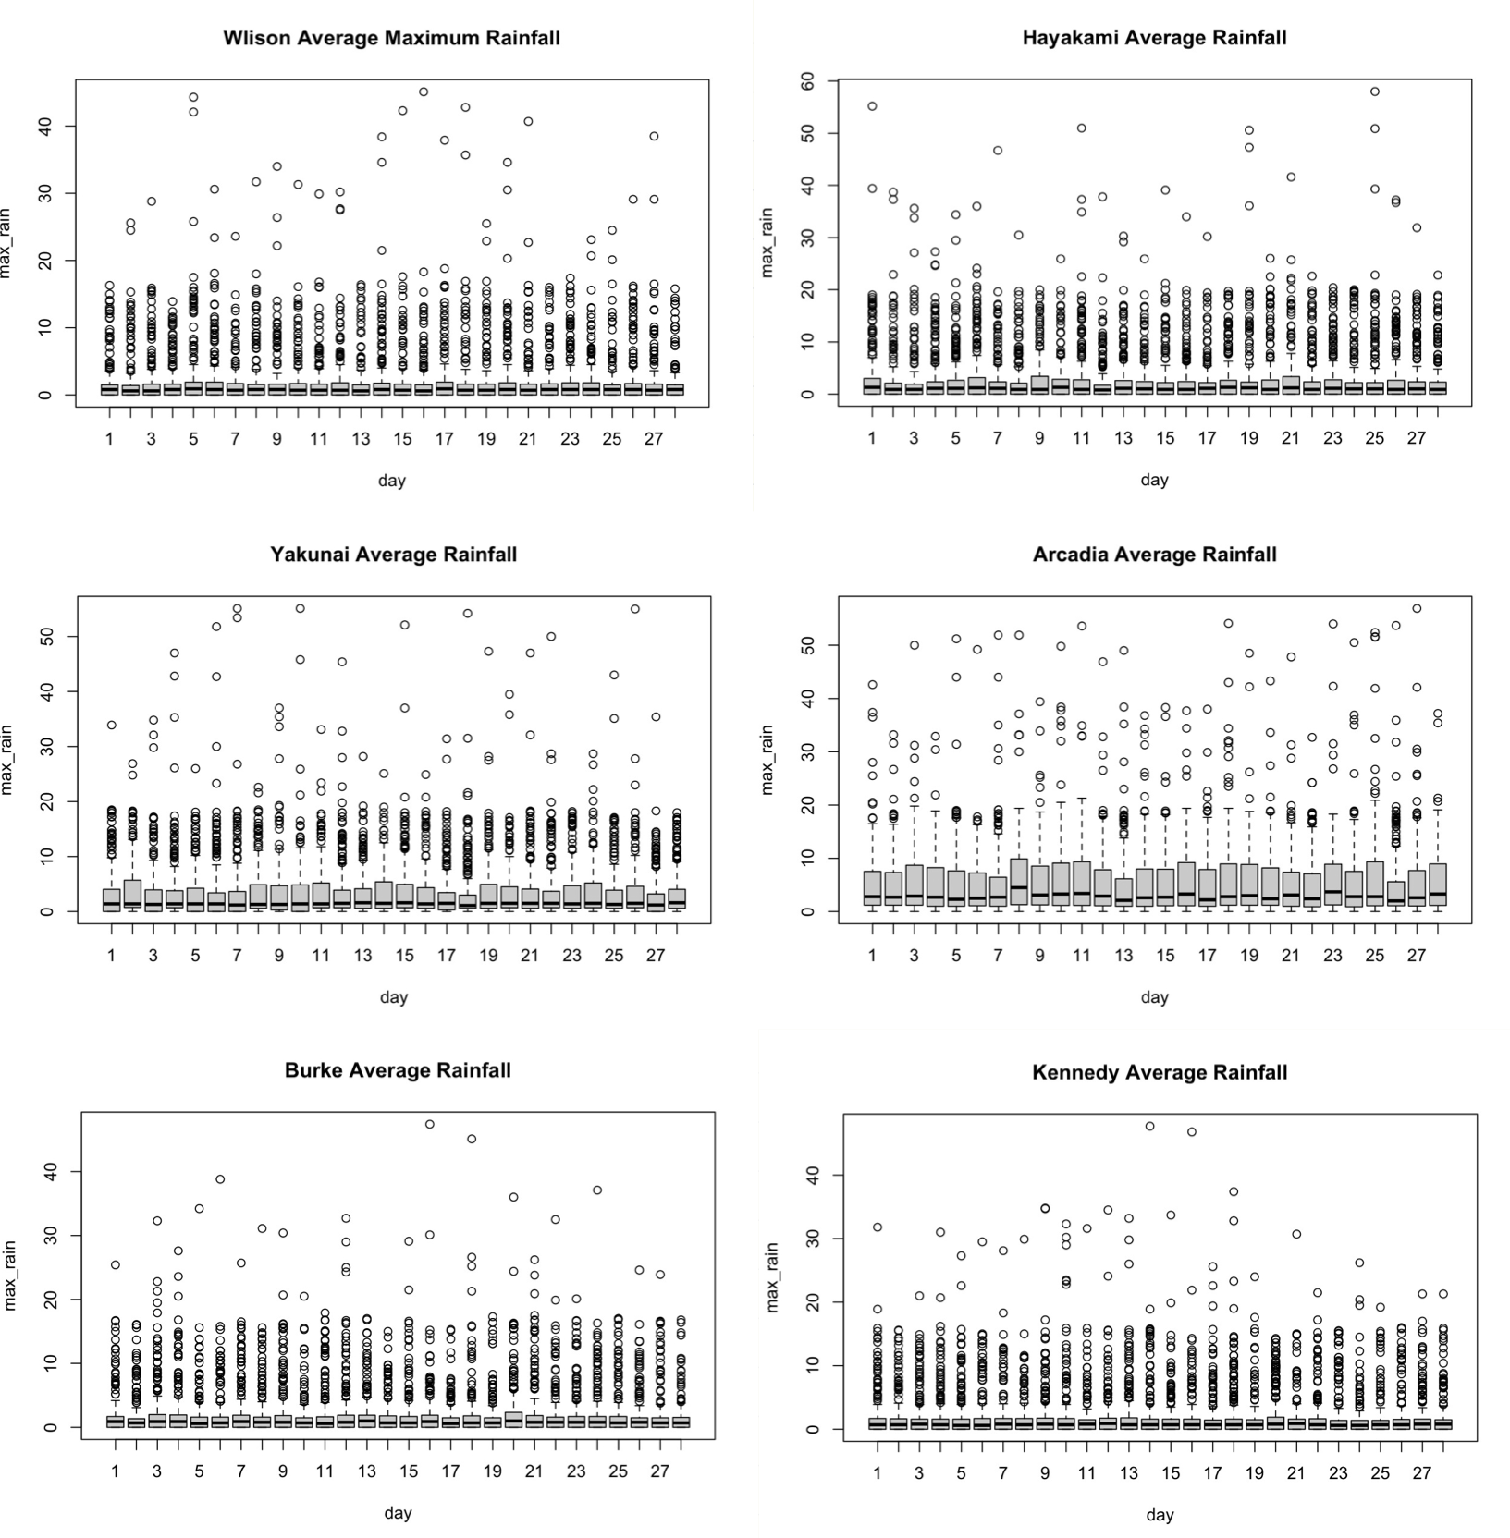



From 6 plots above, all of the stations‘ rainfall centred on nearly 0. Also, Arcadia shows the most centered data and the least outliers among the other 5 plots, then followed by Yakunai, which have the second centred data obtained. While the remaining 4 data shows a similar central tendency and we can regard them as no significant variations in terms of central tendency.

From the rainfall analysis, we can conclude that there is a huge variation of rainfall in the perspective of the amount of rain of the stations. There are also some variations on the central tendency, especially Arcadia and Yakunai in both average rainfall and central tendency analysis.

3. Climate change:

We measured climate change by monitoring the trend of maximum temperature and rainfall along the time series of 203 years (01/135 - 01/337).

As for simplicity, we first take averages of each year among different weather stations with respect to both maximum temperature and rainfall. Then, we use these data to calculate the maximum temperature and rainfall of each year for the whole Island.Finally, we plot the graph and find the slope for the best fitted line. The slope of the best fitted line for maximum temperature and rainfall are 0.0003602149 and 0.0001006172 respectively.

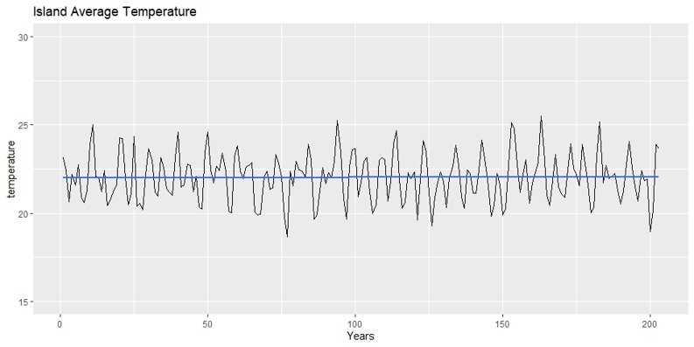

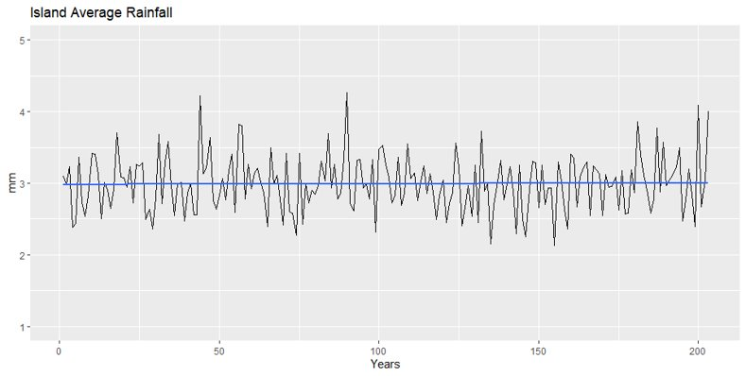

Since the slopes are very small and the changes can be neglected, The Providence has very slight climate change.

4.1 Real-World Comparison

This section is involved in making comparisons to draw connections between the Providence island and a real-world country/region that is most alike in climate, such as temperature and rainfall, and also geographic topology by extension. To start, we deviate from statistics and first take a holistic view of our question, starting with how climate zones are divided in our real-world.

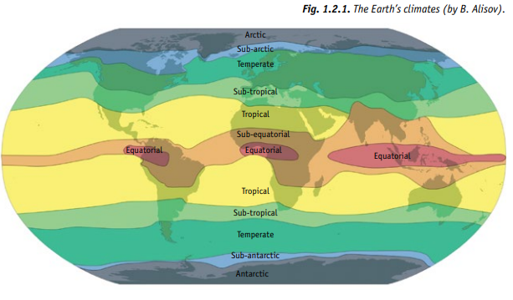

Generally speaking, in the real world, regions are divided into different zones based on their climate and rainfall. The main zones are depicted as follows : equatorial, tropical, temperate, and finally polar. As the names might suggest, the equatorial zone is near the equator while the polar zones are the extremities in both poles of the globe. Since our island in question, the Providence island, which is largely dry due to the the badlands comprising most of the island, definitely does not seem to be a polar zone (characterized by very low temperatures throughout, which is most reminiscent of the Ironbard island) nor a temperate zone (sort of in between, still cold and wet), we narrow down our options to countries in the equatorial, sub-equatorial, tropical, and sub-tropical zones.

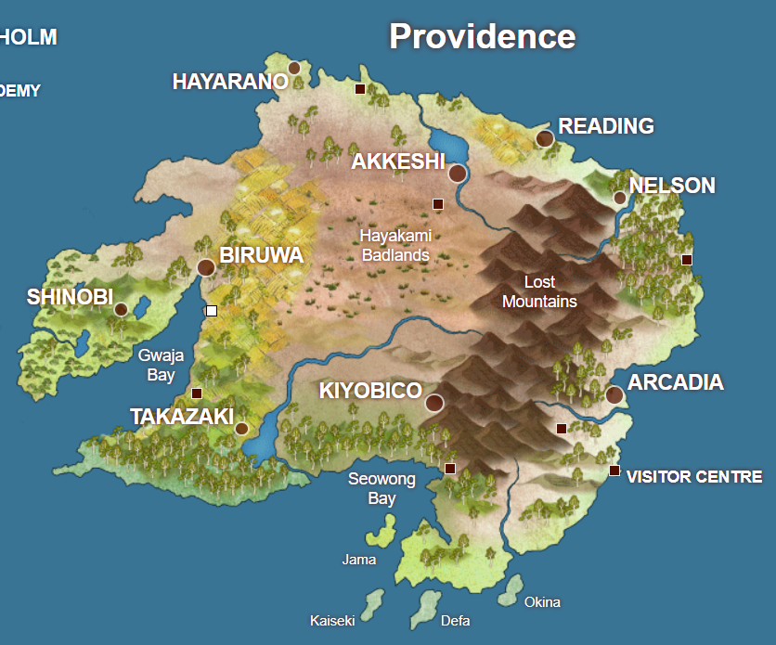

Looking at the map of the Providence island, we notice that while the largest central part is dry and arid due to the badlands, the southern part is notably colder, or wetter, due to the presence of rainforests. To the East of the island past the mountain range, we can also see the same. The conclusion is that climate varies largely due to location in the Providence island; the central part is very dry with no vegetation, but the coastal regions near the south are forested.

In fact, a real-world country exists which exhibits similarities to our observation. Central Australia, which exists mainly in the tropical zone of the Earth, has different climates in Northern and Southern Australia as we may see in the first graph of the climate zones in our planet.

We may draw many similarities of the map of Australia to our island. The largest part of the island, is in its center, which are the dry badlands, coinciding with the deserts of Central Australia. Forested areas in the Providence island coincide with the subtropical regions of the country, where there is more rainfall. Northern Australia is tropical and we see the north of the Providence island starting to break away from the dry badlands and start to grow some vegetation. 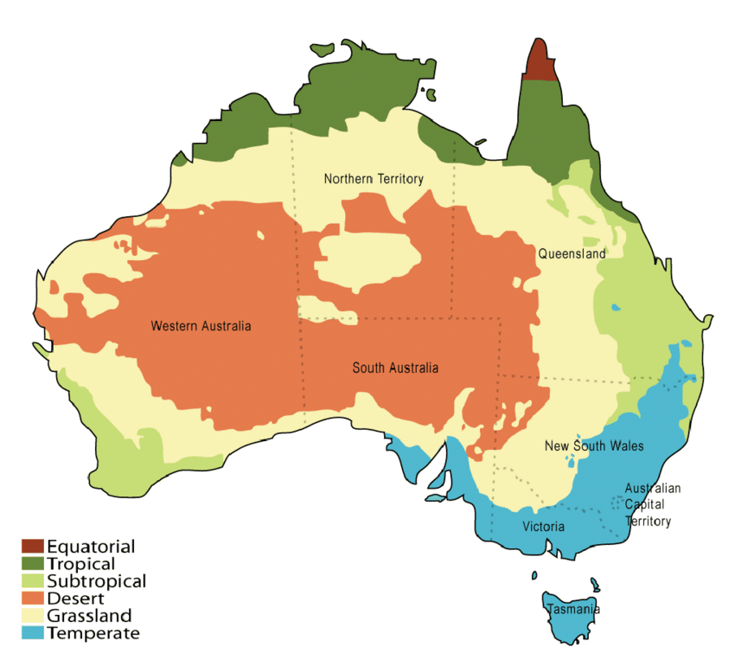

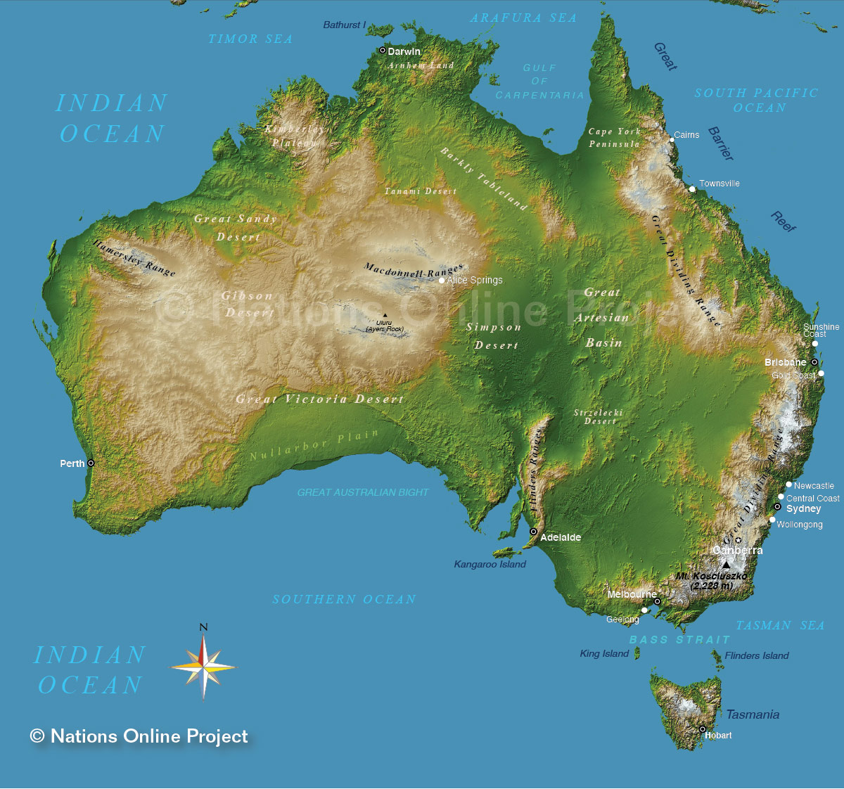

There is a large mountain range in Australia, called the Great Dividing Range, which spans across vertically in the distant east of the country, which is very similar indeed to the mountain range we see in our island. Even Tasmania, the breakaway island in South-East Australia that snows in the winter, coincides with the cooler islands, shown by the change of color from green to turquoise, at the same location of the Providence island.